**Willow Bank Surgery**

**Meir Primary Care Centre, , ,**

**ST3 6AB**

**Telephone number: 0300 123 5002**

Email: [willowbank.y02521@nhs.net](mailto:willowbank.y02521@nhs.net)

Website:willowbanksurgery.nhs.uk

**OPENING TIMES SURGERY TIMES**

**Mon:**  08.30 – 18:00

**Tue:**  08.30 - 18.00

**Wed:**  08.30 - 18.00

**Thu:**  08.30 – 18.00

**Fri:** 08:00 - 18:30 08.30 - 18.00

**Sat:**

**Sun:**  **Please ask at reception for specific**

**Bank Holidays:** Closed **times for Practice Nurse Clinics**.

We offer a late night appointments on Mondays until 8pm

**TELEPHONE NUMBERS**

**Emergencies, Visits and Out of Hours**

0300 123 5002 or NHS 111 (out of hours)

**Appointments**

0300 123 5002

**Enquiries and Results**

0300 123 5002 after 12:00pm please

**Business & Enquiries**

**Tel** 0300 123 5002

**PRACTICE STAFF**

Dr Sri Sundaram - GP (Male)

Dr Bala Sankarasubbu (Female)

Dr Ratladi – GP (Male)

Dr Uday Katkar – GP (Male)

Dr Amir Majeed – GP (Male)

Dr David Weldon – GP (Male)

Dr Sandyha Dhingra GP (Female)

Bev Heath - Practice Manager

**We also have a full complement of additional clinical staff and administration teams.**

**We also use the services of the Midwife & Health Visitor, District Nurse & Community Matron**

**Smoking Cessation Advisor**

**Counsellor**

**Please contact the surgery for details**

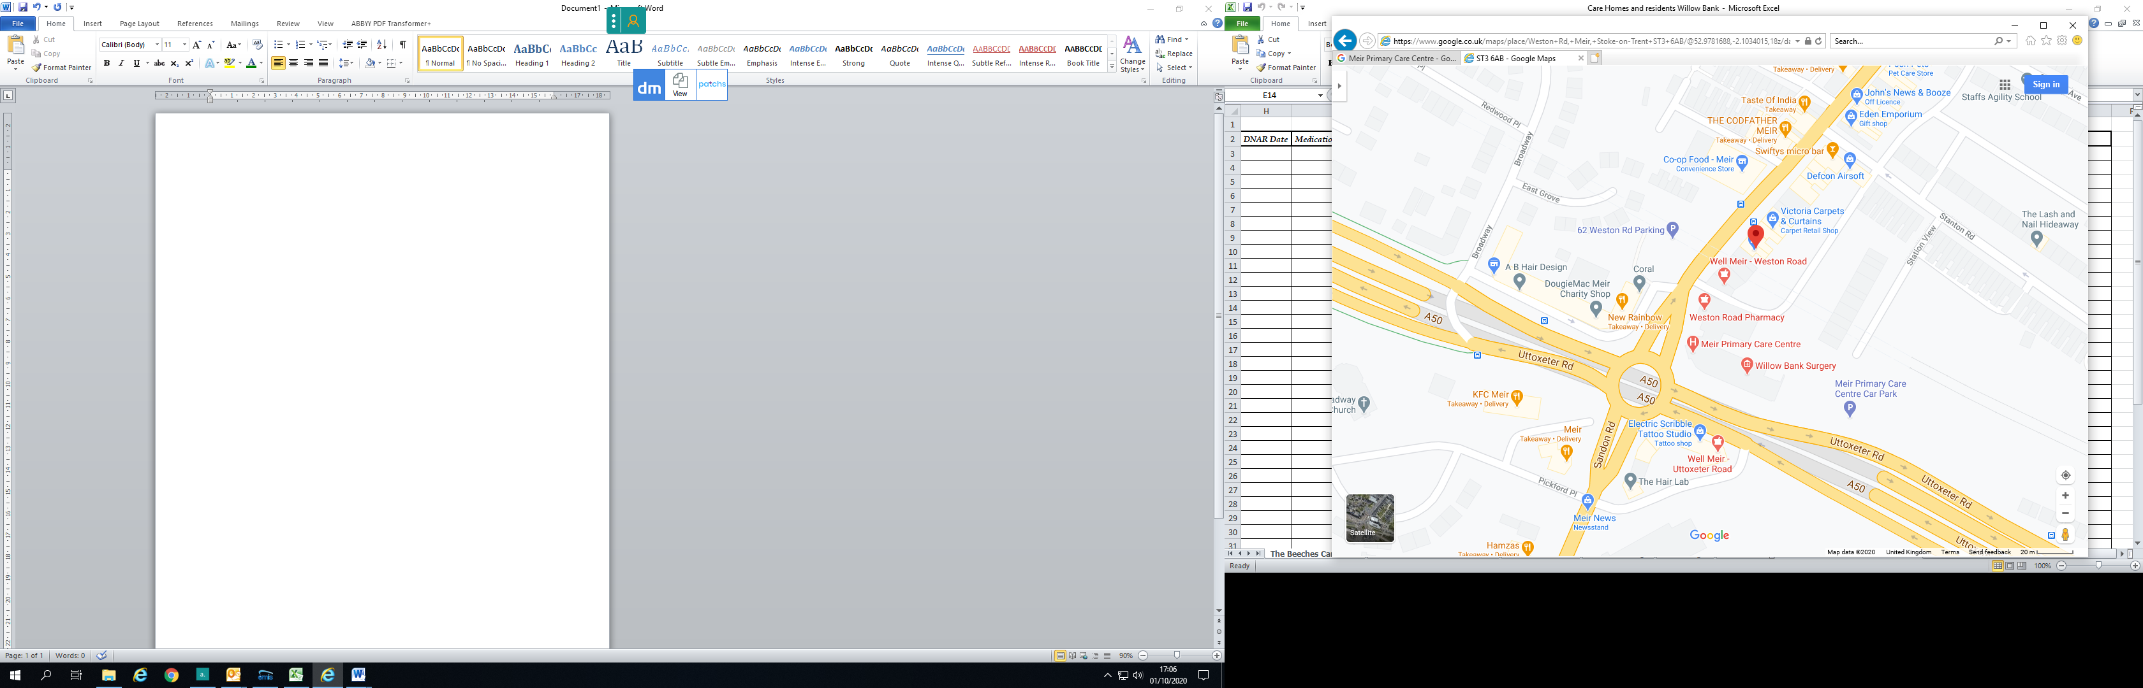

|  |  |
| --- | --- |
| |  | | --- | | **Willow Bank Surgery** |   PRACTICE  LEAFLET  Information for  Patients |

The Freedom of Information Act gives you the right to request information held by a public sector organisation.

Unless there’s a good reason, the organisation must provide the information within 20 working days.

Please contact Bev Heath, Practice Development Manager.

There may be a charge for this information.

General Practitioners

Dr Sri Sundaram MBBS, MRCGP, DFFP,

P.G. Diploma (Diabetes & Endocrines)

Dr Bala Sankarasubbu, MBBS, DFSRH, DRCOG, MRCGP

**Please note the named allocated GP and named accountable GP for all registered patients & patients over the age of 75 years is: Dr. Sri Sundaram**

[](https://www.facebook.com/adderley-green-surgery)  **Find us on Facebook:**

**https://www.facebook.com/willowbankmeirAPPOINTMENTS**

All surgeries are by appointment, and can be made in person by telephone or on line. Please ask at reception to register for on line access. We use a scheme called Advanced Access where we are able to offer same day Dr’s appointments-therefore there is no need to book your appointments in advance. We also do still offer an amount of pre-booked appointments if needed. If you are unable to attend for your appointment please let us know so that we can offer this to another patient. **Please note during the Covid pandemic we are using a system of telephone triage. The clinician will then decide if a face to face appointment is required.**

**URGENT APPOINTMENTS**

We will still have urgent appointments each day for the Dr, Nurse Practitioner and the Nurse. Please telephone the surgery as early as possible for emergencies.

**Practice Nurse & Health Care Assistant**

We have nursing staff available for BP checks, Asthma, Diabetic and COPD checks, NHS Health Checks, ear syringing, vaccinations, cervical smears, dressings and any other routine nursing duties.

**Nurse Prescribers & Paramedic**

We have a team of Nurse Practitioners and a Paramedic available who can see and treat all minor ailments. We have a Mental Health Practitioner to support mental health problems who is also a prescriber. We also have a prescribing Diabetes Specialist Nurse to support our diabetic patients.

**HOW TO REGISTER AS A PATIENT**

The practice has an open list and is registering new patients whether new to the area or not. Please ask for a registration form at reception or register on line via our practice website. Following your registration you will be required to have a new patient check to enable your registration to be fully complete. An appointment will be offered with our Health Care Assistant during your registration.

**HOME VISITS**

Home visits should only be requested for those who are unable to come to the Surgery because of serious illness and infirmity. **They should be requested before 10:30am if at all possible.**

**Queries**

We have a duty doctor to answer any queries. Please ask the reception staff to be put into the duty book for any queries that you may have that may not require an appointment.

**PRESCRIPTIONS**

**ROUTINE**— requests for repeats prescriptions will be dealt with within 2 working days or 48 hours. Requests for prescriptions are not taken over the telephone. Requests can be made in person – drop in the box provided in reception, online or by using local pharmacy services. Please ask at reception to register for online services if you don’t already have this.

**URGENT**-requests for urgent prescriptions may be made by telephone and will be ready by 6:00pm the same day.

**CHAPERONES**

All patients are entitled to have a chaperone present for any consultation. Please request this at the time of booking or speak to your GP. Please ask to see our practice policy if further information is required.

**OUT OF HOURS**

If you have an urgent problem when the surgery is closed, please ring **NHS 111** you will then be signposted to the correct service for you.

At weekends and Bank Holidays the surgery is closed. For URGENT problems only telephone **NHS 111**

**Other numbers you can use in an emergency**

**Hanley Health & Wellbeing Centre: 0300 123 6759**

**Midway Medical & Walk in Centre: 01782 663757**

**Haywood Walk in Centre, High Lane, Burslem: just walk in open 7am -10pm (9am-10pm at weekends)**

**Out Of Hours: 111**

**PLEASE CALL THESE NUMBERS BEFORE ANY ATTENDANCE AT A&E, unless you have a life threatening emergency then call 999**

**DISABLED ACCESS**

There is very good access available for patients who have a disability. There is a lift to access the practice reception and disable parking spaces available close to the main entrance.

**TRAINING & TEACHING PRACTICE**

We are an accredited training practice in collaboration with West Midlands Deanery &Keele Medical School. We have trainee GPs as well as medical students in practice .We would value your support, but understand if you do not want to consult with a student.

**RESEARCH**

As a member of the Primary Care Research Network in partnership with Keele University, you may be asked from time to time to participate in research projects.

We would appreciate your co-operation with this, but we understand if you do not want to be involved.

**GDPR**

All information held about patients is completely confidential. The Practice is registered under the Data Protection Act 1998. This Act protects data held on the computer system. See our patient privacy notice

**OTHER LEAFLETS**

You will find a wide variety of Practice Leaflets which will inform you of all the services that we provide for our patients. These include a **Comments and Complaints leaflets**. Please ask at reception if there are any other leaflets which you specifically require.

To obtain details of all primary medical services available within the NHS in Stoke-on-Trent please contact:

**PCSE customer service centre:**

**TEL: 0333 014 2884**

**Your Views – Have Your Say**

We have a **Patient Participation Group** who meets on a regular basis. We would welcome new members. Please ask at reception for further information.

**Patient Advisory & Liaison Services (PALS)**

**Freephone: 0800 0304563**

***(Revised 27 May 2021)***o0fksp1p[1]